9a output screenshot
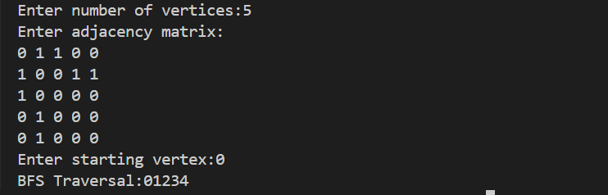

9b output screenshot
